COMPUTER STATISIC
QUIZ 1 – WEEK 4



KHEN MUHAMMAD CAHYO
244107023002
TI-2I
STATE POLYTECHNIC OF MALANG
INFORMATION TECHNOLOGY DEPARTMENT

UNDERSTANDING VARIABLE
- Answer Question 1
- Ordinal Variable (Categorical)
  - Overall rank: The result of calculating happiness data (Dependent)
- Nominal Variable (Categorical)
  - Country or region: Only the identification variable can be observed
- Continous Variable (Numeric)
  - Score: Main variable explained by other variables (Dependent)
  - GDP per capita (Independent)
  - Social support (Independent)
  - Healthy life expectancy (Independent)
  - Freedom to make life choices (Independent)
  - Generosity (Independent)
  - Perceptions of corruption (Independent)
GDP per capita, Social support, Helathy life expectancy, Freedom to make life choices, Generosity, and Perceptions of corruption are factor variables that are thought to influence happines Score variable.

CENTRAL TENDENCY
- Answer Question 1
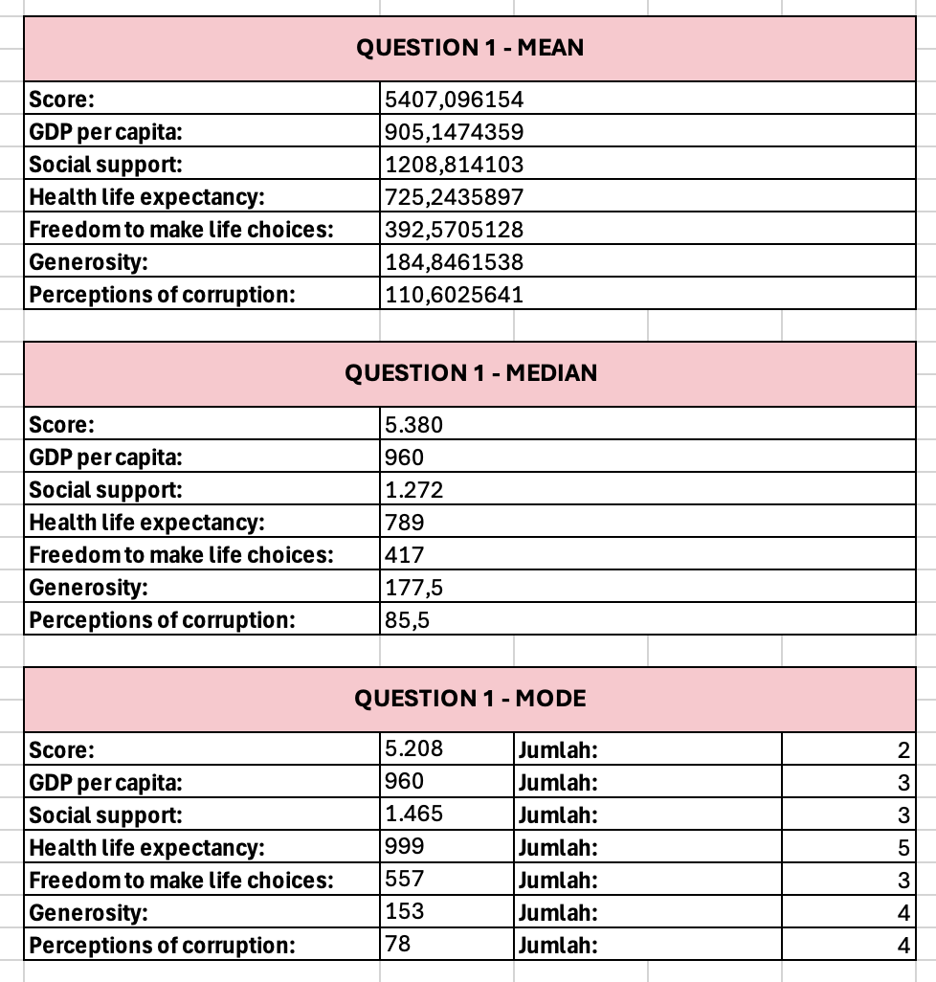
- Answer Question 2
  - Happiness Score
Mean: ~5407.1
Median: ~5.380
The mean (average) and median (middle value) are almost the same. It means that most countries have happiness scores clustered around the middle. There are no extreme outliers (very few countries with extremely high or low happiness)
  - Generosity
Mean: ~184.8
Median: ~177.5
The mean (average) is higher than the median (middle value). It means that few countries are extremely generous, pulling the average up. Most countries, however, have generosity levels closer to the median (177.5).

VARIABILITY OF DATA
- Answer Question 1
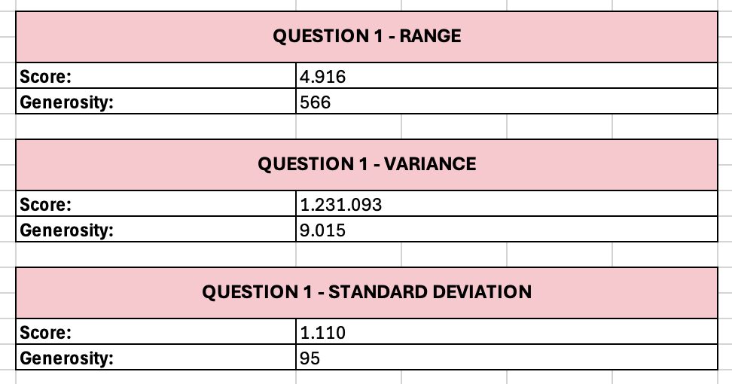
- Answer Question 2
  - Happiness Score = 1.110
Happiness scores are very close together. It means that most countries have similar happiness levels—there’s not much difference between them.
  - Generosity = 95
Generosity scores are very spread out. It means that countries are very different in how generous they are—some are super generous, while others are not.
- Answer Question 3
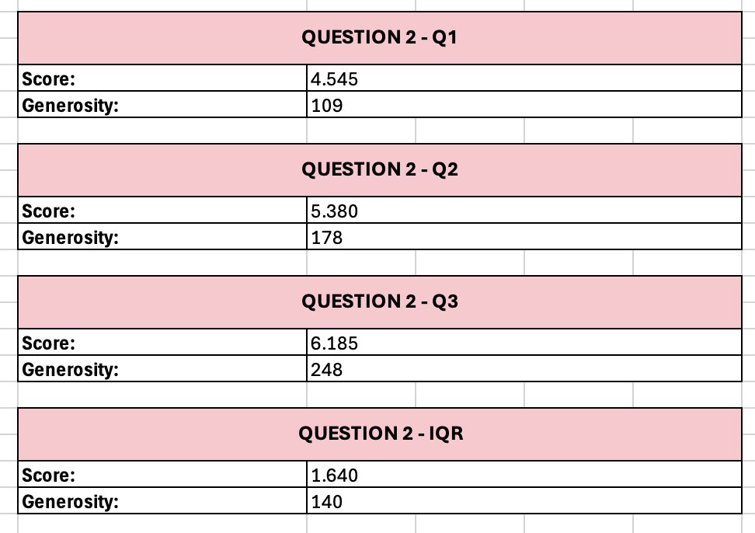
- Answer Question 4

DATA VISUALIZATION
- Answer Question 1
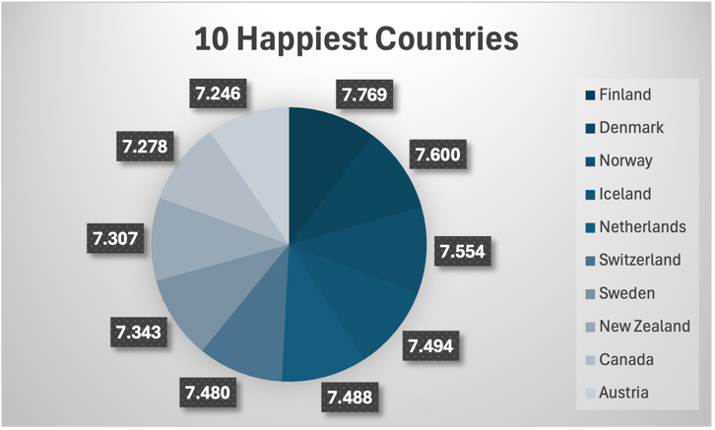
- Answer Question 2
- Answer Question 3
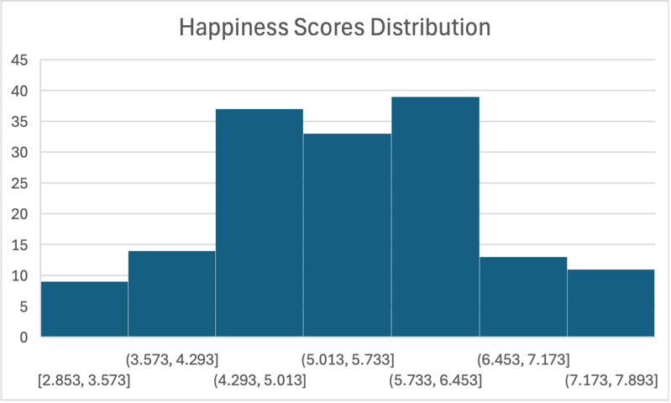
- Answer Question 4

